DML commands

CREATE Table Employee_71(Emp_id int primary key, Emp_name varchar(30), Dept varchar(20),salary DECIMAL(10,2));
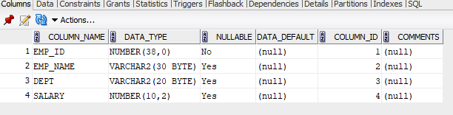

INSERT INTO Employee_71 VALUES(1, 'David Smith', 'Marketing', 7500.00);
INSERT INTO Employee_71 VALUES(2, 'Olivia Johnson', 'HR', 6800.00);
INSERT INTO Employee_71 VALUES(3, 'Charles Brown', 'Sales', 7200.00);
INSERT INTO Employee_71 VALUES(4, 'Alice White', 'Production', 6400.00);
INSERT INTO Employee_71 VALUES(5, 'Daniel Green', 'Marketing', 9000.00);

1)SELECT * FROM Employee_71 WHERE salary > 70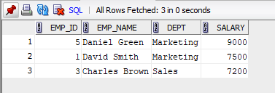00;

2) UPDATE Employee_71 SET Salary = 8200.00 WHERE Emp_name = 'David Smith';

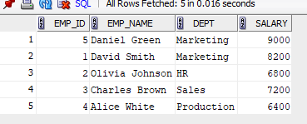
3) INSERT INTO Employee_71 VALUES (6, 'Daniel Harris', 'Production', 6700.00);
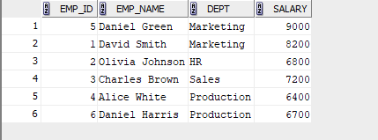
4) DELETE from Employee_71 where emp_id =3;
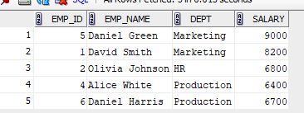
5) SELECT * FROM Employee_71 WHERE Emp_name NOT LIKE 'D%' AND Emp_name NOT LIKE 'O%';
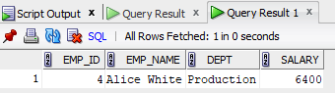
6) SELECT Dept, SUM(salary) AS Total_Salary FROM Employee_71 GROUP BY Dept;
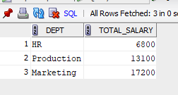
7) UPDATE Employee_71 SET Salary = Salary * 1.05 WHERE Dept = 'Production';
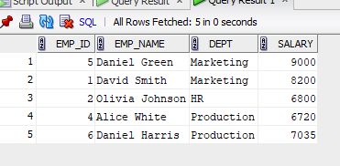
8) DELETE FROM Employee_71 WHERE salary < 7000;
